**FERTILIZER RECOMMENDATION SYSTEM FOR DISEASE PREDICTION**

**FUNCTIONAL REQUIREMENTS**

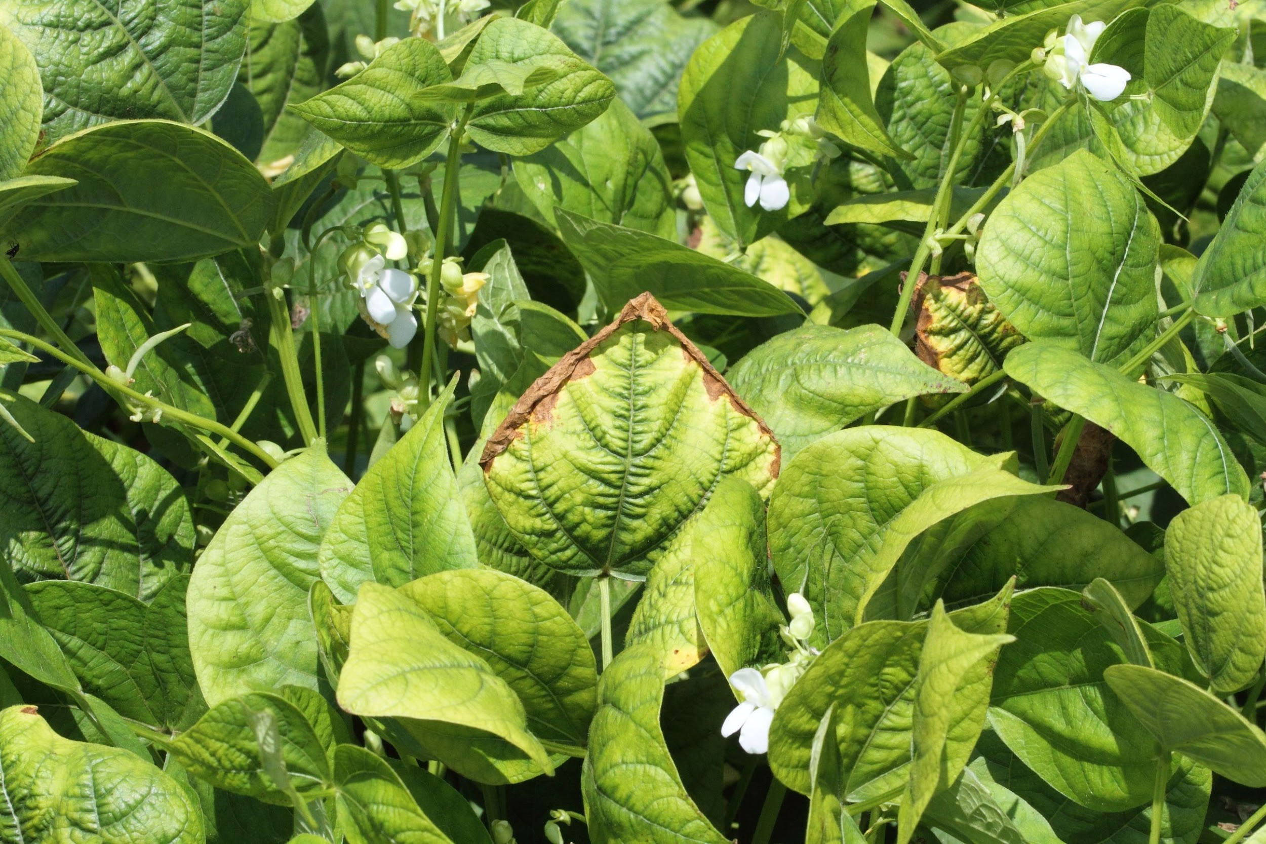

**There are two components of NLP as given in debatable situations: the proposed device has an added benefit of suggesting fertilizer for the farmer primarily based on the crop predicted.**

**Here the Nitrogen Phosphate and Potassium are the 3 simples’ crucial minerals for crop growth and consequently fertilizer recommendation is primarily based on these three values.**

**If there may be the most desirable availability of those primary nutrients in the soil, then no fertilizers are required. When there takes place the deficiency of nutrients then the fertilizers are suggested**

**OPERATIONAL REQUIREMENTS**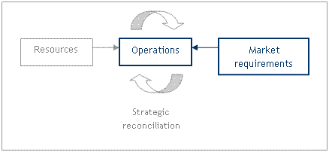

* **Expansion of the newly reclaimed area.**
* **Crop rotations and their impact on crop responses to fertilizers.**
* **Soil and plant tissue analysis.**
* **The fertilizing value of the various sources of fertilizers.**
* **Residual effect of the fertilizers and the organic manures.**
* **Scheme structure**
* **Ongoing programmes on soil health management**
* **Scheme components**
* **Scheme objectives**
* **Soil testing programme**
* **Nutrient status of soils**

**TEAM INFORMATION:**

| **NAME** | **1.MATHIARASI.J(TEAM LEAD)**  **2.KAVIPRIYA.R**  **3.SANDHIYA.P**  **4.MAMTHA.M**  **5.SAABIRA.S** |
| --- | --- |
| **DATE** | **31 October 2022** |
| **MAXIMUM MARKS** | **4 Marks** |
| **MARKS ALLOTTED** |  |